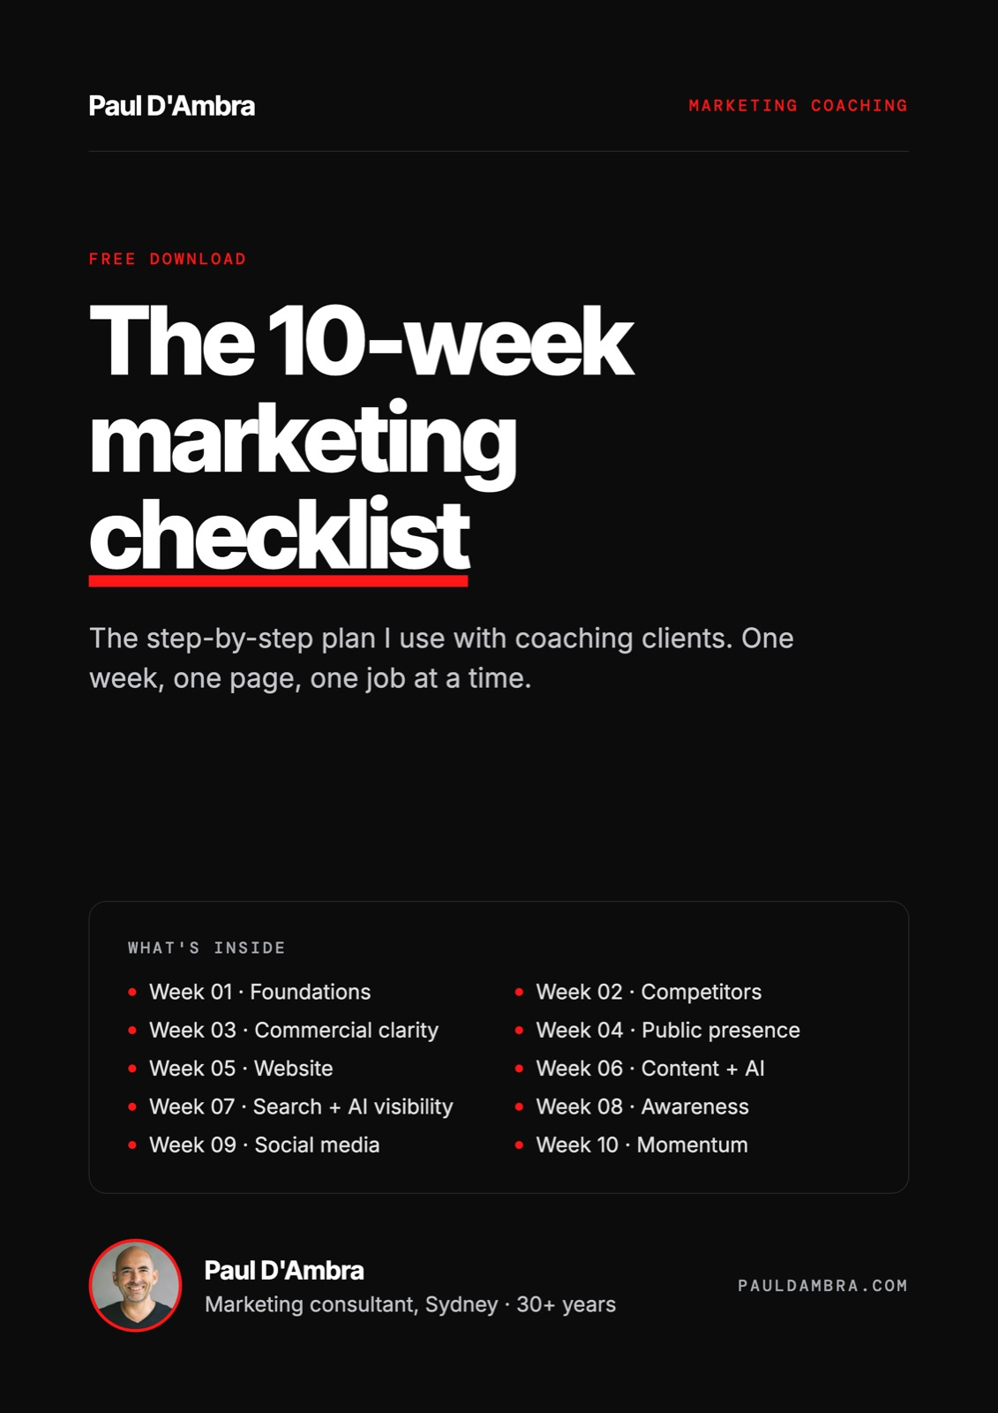

How to use it
One week, one page
The plan I use with coaching clients, step by step

This is the exact order I work through with business owners in my 10-week marketing coaching program. Do one week at a time. Don't skip Week 1, and don't buy ads before Week 5 is done.
Each week is on its own page. Print the week you are working on, tick things off as you go, and only move on when the boxes are ticked.
Week 01 · Foundations

Your market, your customer, your difference

☐ Name your primary market: a location or a niche
☐ Estimate how many people search for what you do
☐ Describe your ideal customer: who they are, what they worry about, how they decide
☐ List every direct competitor and what they say about themselves
☐ Write one sentence that tells a stranger why you, not them
☐ List every channel you use now and mark it working, not working or unsure
☐ Set one 10-week goal and two numbers to track every week

NOTES
Week 02 · Competitors

Know who you're up against

☐ List direct, indirect and search competitors
☐ Note each one's headline, main claim and pricing
☐ Check what phrases they show up for and whether they run ads
☐ Ask ChatGPT or Gemini who they recommend for what you do
☐ Find the questions customers ask that nobody answers well
☐ Write down the single biggest opening for you

NOTES
Week 03 · Commercial clarity

What you sell and what you charge

☐ List every service, including the ones you do informally
☐ Mark each one for revenue, profit and whether you enjoy it
☐ Give every service a name a stranger understands
☐ Create an entry-level, core and premium version
☐ Compare your prices with three competitors
☐ List what your top 10 clients could buy that they don't yet

NOTES
Week 04 · Public presence

What people find when they look you up

☐ Claim and complete your Google Business Profile: categories, services, photos, hours
☐ Make your name, address and phone identical everywhere
☐ Ask five happy clients for a review this week
☐ Write reply templates for good and bad reviews
☐ Fix your bios, photos and links on every social profile
☐ Check True Local, Yellow Pages, Yelp and industry directories

NOTES
Week 05 · Website

Does it explain, convince and convert?

☐ Rewrite your homepage headline: what you do and who for, in 8 words
☐ Make sure a call to action shows on mobile without scrolling
☐ Make your phone number tap-to-call and your form 4 fields or less
☐ Add a testimonial and a real photo near the top
☐ Run Google PageSpeed Insights and note the biggest problems
☐ Check GA4 is tracking calls, forms and bookings
☐ Fix the three most important problems this week

NOTES
Week 06 · Content + AI

Content that gets found, written faster with AI

☐ Find 10 to 15 phrases your customers search for
☐ Group them: ready to buy, researching, local
☐ Plan three pieces of content with a target phrase and publish date
☐ Write an AI brief: your customer, your difference, your proof, your tone
☐ Use AI for first drafts only. Check every fact and add real examples
☐ Publish content piece #1

NOTES
Week 07 · Search + AI visibility

Getting found on Google and in AI answers

☐ Check Search Console for errors and pages with impressions but few clicks
☐ Fix titles, descriptions, H1s and alt text on your 5 most important pages
☐ Make sure each page links to at least two others
☐ Ask ChatGPT, Gemini and Perplexity who they recommend in your area
☐ Add clear answers and FAQs to the pages that matter
☐ List five websites that could genuinely link to you
☐ Publish content piece #2

NOTES
Week 08 · Awareness

The two tactics that suit you

☐ Score Google Ads, Meta ads, PR, referrals, associations and email
☐ Don't buy traffic until your website converts
☐ List five businesses with the same customer who could refer you
☐ Write one 150-word media or podcast pitch
☐ Send one short, personal email to past clients
☐ Pick two tactics and do one properly before starting the second

NOTES
Week 09 · Social media

A system that doesn't take over your life

☐ Choose one platform and write down why
☐ Set four pillars: proof, education, behind the scenes, offers
☐ Plan four weeks at three posts a week
☐ Use AI to turn one idea into a week of posts
☐ Schedule two weeks ahead with Meta Business Suite, Buffer or Later
☐ Publish content piece #3

NOTES
Week 10 · Momentum

Your numbers, your routine, your next 90 days

☐ Record your five weekly numbers: sessions, organic sessions, conversions, Google profile actions, top page
☐ Compare Week 1 with Week 10
☐ Send five review requests every Friday
☐ Write a one-page monthly routine you can run alone
☐ Choose your 90-day priority and set the first action

NOTES
After Week 10

Your monthly routine
Week 1 | Publish one piece of content. Send five review requests. Check your numbers.
Week 2 | Post to your social schedule. Review Search Console.
Week 3 | Publish one piece of content. Reply to every review.
Week 4 | Compare with last month. Pick one priority for next month.

