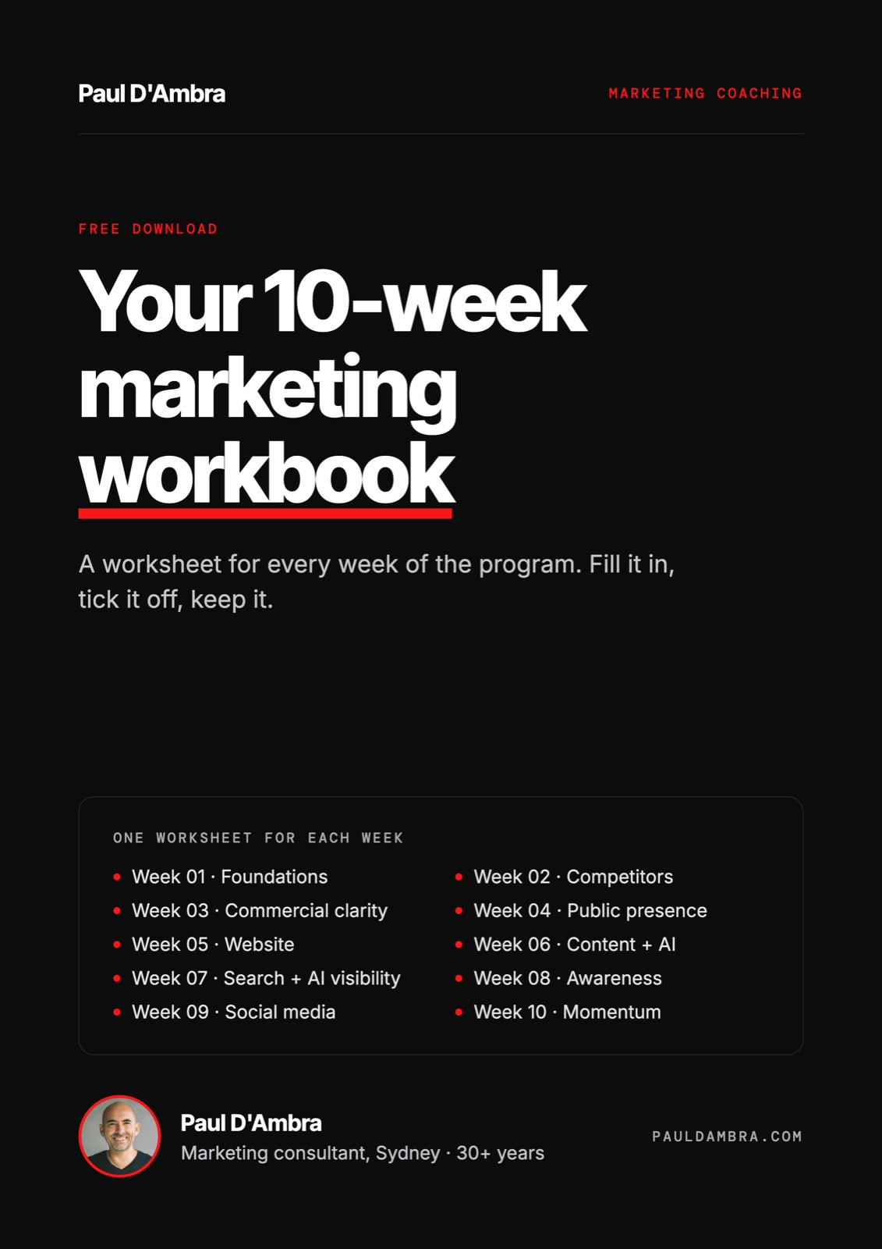

10-week marketing coaching
How to use this workbook
One worksheet for every week of the program

This workbook has one worksheet for each week of the program. Every section starts on its own page, so you can print the week you're working on.
How to use it
☐ Fill in what you can before each session. Blank is fine.
☐ Write your agreed actions in the table at the end of each week.
☐ Tick them off before the next session, not the night before.
☐ Keep it. Everything you build in here is yours.
What's inside
Week 01 | Foundations: Your market, your customer, your difference
Week 02 | Competitors: Know who you're up against
Week 03 | Commercial clarity: What you sell and what you charge
Week 04 | Public presence: What people find when they look you up
Week 05 | Website: Does it explain, convince and convert?
Week 06 | Content + AI: Content that gets found, written faster with AI
Week 07 | Search + AI visibility: Getting found on Google and in AI answers
Week 08 | Awareness: The two tactics that suit you
Week 09 | Social media: A system that doesn't take over your life
Week 10 | Momentum: Your numbers, your routine, your next 90 days

Week 01 · Foundations
Your market, your customer, your difference
10-week marketing coaching · Paul D'Ambra

Nothing gets executed until we know who you're selling to and why they should pick you. Most marketing fails because this step gets skipped. Fill in what you can before the session. Leave the rest and we'll do it together.
Your market

How big is the opportunity?
Primary market (location or niche)
Roughly how many people or businesses search for what you do?
Is the market growing, stable or shrinking? How do you know?
Your ideal customer

Who exactly are you trying to reach?
Who they are (age, location, business size, industry)
What they worry about
What they want
How they search, compare and decide
Where they spend time online and offline
Your difference

Why you over everyone else?
Competitor | What they say about themselves

The one or two things that are genuinely different about you
Your USP in one sentence a complete stranger would understand
What you already have

Every channel, tool and platform you use now
Channel / platform | Working? (yes / no / unsure) | Keep, fix or drop

The single biggest gap between where you are and where you want to be
Your 10-week goal

What does success look like by Week 10?
Primary goal (e.g. 10 new enquiries a month)
Supporting number 1
Supporting number 2
How and when we will measure it each week
Session outcome
YOU LEAVE WITH
A one-page marketing foundation: your market, your customer, your USP and your 10-week goal. It also becomes the brief your AI tools work from in Week 6.
After the session

Actions agreed this session
Be specific. Each one should be something you can tick off before the next session.
# | Action | By when | Done
1
2
3
4
5
Notes

Week 02 · Competitors
Know who you're up against
10-week marketing coaching · Paul D'Ambra

What competitors say, where they show up and where they are weak shapes everything that follows: your website, your content, your keywords and how you position yourself.
Competitive landscape

Direct, indirect and search competitors
Competitor | Type (direct / indirect / search) | Headline or USP claim | Pricing vs yours | Biggest weakness
Search and AI presence

Where do they show up?
Competitor | Phrases they show up for | Running ads? For what? | Do AI tools recommend them?
Social media and content

What are they doing and what works?
Competitor | Platforms | How often they post | What works best for them
Gaps and opportunities

Where the market is under-served
Questions customers ask that nobody answers well
Services they don't offer or don't promote clearly
Customers they seem to ignore
Weak spots in their reputation (reviews, complaints, poor content)
Your gap summary

The one thing to act on
The single most important opportunity this has revealed for you
Session outcome
YOU LEAVE WITH
A one-page competitor gap summary: where the market is crowded, where it is under-served and where you have the clearest opening.
After the session

Actions agreed this session
Be specific. Each one should be something you can tick off before the next session.
# | Action | By when | Done
1
2
3
4
5
Notes

Week 03 · Commercial clarity
What you sell and what you charge
10-week marketing coaching · Paul D'Ambra

Before sending traffic anywhere, your offer needs to make sense to a stranger and make money for you.
Service inventory

Everything you sell, including the informal stuff
Service | Revenue (H / M / L) | Profit (H / M / L) | Enjoy doing it? | Would a stranger understand the name?
Packaging

An entry point, a core offer and a premium option
Entry-level version
Core version
Premium version
Recurring option (retainer, membership, maintenance plan)
Pricing against the market

Use your Week 2 competitors
Service | Your price | Competitor 1 | Competitor 2 | Competitor 3

Too low, about right or premium? Why?
Should your pricing be on your website?
Existing clients

The easiest revenue you have
Client | Services they use now | Services they could use | Next step
Session outcome
YOU LEAVE WITH
A clearly named service menu with outcome-focused descriptions, pricing that matches your position, and a list of opportunities with existing clients.
After the session

Actions agreed this session
Be specific. Each one should be something you can tick off before the next session.
# | Action | By when | Done
1
2
3
4
5
Notes

Week 04 · Public presence
What people find when they look you up
10-week marketing coaching · Paul D'Ambra

Before a stranger contacts you, they check Google, Facebook, LinkedIn and directories. Gaps here lose enquiries before anyone reaches your website.
Google Business Profile

Getting seen locally
☐ Claimed and verified
☐ Name, address and phone match your website exactly
☐ Most specific primary and secondary categories selected
☐ Description uses your key search phrases naturally
☐ Every service listed with its own description
☐ Hours, public holidays and special hours set
☐ At least 10 photos: outside, inside, team, work, logo
☐ First post published this week
Reviews

A system, not a hope
Happy client to ask this week | Phone or email | Request sent?

Your direct review link
Your reply template for a positive review
Your reply template for a negative review (never argue in public)
Profile consistency

Same story everywhere
Platform | Bio says what you do and for who? | Photo consistent? | Link goes to the right page? | Handle matches?
Google
Facebook
Instagram
LinkedIn
Other
Other
Directories

Fix the wrong and the duplicates
Directory | Listed? | Name, address, phone correct? | Fixed?
True Local
Yellow Pages
Yelp
Industry directory
Industry directory
Session outcome
YOU LEAVE WITH
Every public profile complete and consistent, the first review requests sent, and a Google Business Profile posting routine.
After the session

Actions agreed this session
Be specific. Each one should be something you can tick off before the next session.
# | Action | By when | Done
1
2
3
4
5
Notes

Week 05 · Website
Does it explain, convince and convert?
10-week marketing coaching · Paul D'Ambra

Most small business websites already get visitors they don't convert. We fix that before you pay for more traffic.
Homepage message

Can a stranger tell what you do in five seconds?
Your homepage headline now
Rewritten: what you do and who for, in eight words or less
Words to remove (experienced, professional, quality, passionate...)
Contact friction

How hard is it to get in touch?
☐ Contact is two clicks or fewer from the homepage
☐ Phone number is tap-to-call on mobile
☐ Contact form has four fields or fewer
☐ There is a booking, chat or callback option
☐ A clear call to action shows on mobile without scrolling
Mobile, speed and trust

Check it on your own phone
☐ Text readable without zooming
☐ Buttons easy to tap
☐ A testimonial visible on the homepage
☐ Logos, credentials or certifications shown
☐ A real photo of you or your team

PageSpeed score: mobile / desktop
Biggest performance problems
Tracking

If it is not measured, it did not happen
☐ GA4 installed and recording on every page
☐ Calls, form submissions and bookings tracked as conversions
☐ Your own visits excluded
☐ GA4 connected to Search Console
Your fix list

Prioritised, with the top three done this week
Priority | Fix | Who does it | By when | Done
1
2
3
4
5
6
7
8
Session outcome
YOU LEAVE WITH
A prioritised website fix list, with the three most important changes made this week.
After the session

Actions agreed this session
Be specific. Each one should be something you can tick off before the next session.
# | Action | By when | Done
1
2
3
4
5
Notes

Week 06 · Content + AI
Content that gets found, written faster with AI
10-week marketing coaching · Paul D'Ambra

We plan content around what your customers actually search for, then set up AI as a writing assistant that works from your Week 1 foundation, so it sounds like you and not like everyone else.
Keyword research

What your customers type in
Phrase | Type (buying / researching / local) | Already showing for it?
Three-piece content plan

One piece a week for the next three weeks
# | Topic | Target phrase | Format | Call to action | Publish date
1
2
3
Existing content

Keep, improve or merge
Page | Traffic | Enquiries | Keep / improve / merge
Your AI brief

Paste this into ChatGPT, Claude, Gemini or Copilot before you ask it to write anything
Who my customer is
What they worry about
What makes me different
Proof I can use (results, reviews, numbers)
My tone of voice in three words
Words and phrases I never use
Things AI must never make up (prices, results, claims)
What stays human

AI drafts. You decide.
☐ Real results, numbers and client stories
☐ Your opinions and recommendations
☐ Prices, guarantees and promises
☐ Every fact checked before it is published
Session outcome
YOU LEAVE WITH
A three-piece content plan, a reusable AI writing brief, and content piece #1 published.
After the session

Actions agreed this session
Be specific. Each one should be something you can tick off before the next session.
# | Action | By when | Done
1
2
3
4
5
Notes

Week 07 · Search + AI visibility
Getting found on Google and in AI answers
10-week marketing coaching · Paul D'Ambra

People now ask ChatGPT, Gemini, Perplexity and Google's AI Overviews who to call. The fundamentals that win on Google are also what these tools read, so we work on both.
Search Console review

What Google already thinks of you
Pages with errors or warnings
Pages with lots of impressions but few clicks
Your highest-traffic pages
Your five most important pages

On-page basics
Page | Title under 60 characters? | Description under 160? | One H1? | Image alt text? | Links to 2+ pages?
AI visibility test

Ask the tools what your customers would ask
Question asked | Tool | Are you mentioned? | Who is?
Local SEO

Make your location obvious
☐ Name, address and phone identical everywhere
☐ Suburb and city mentioned naturally on service pages
☐ A page for each area you actively serve
Links from other websites

Who could genuinely link to you?
Website | Relationship | What they could link to | Asked?
Session outcome
YOU LEAVE WITH
Critical SEO issues fixed on your five key pages, an AI visibility baseline, and content piece #2 published.
After the session

Actions agreed this session
Be specific. Each one should be something you can tick off before the next session.
# | Action | By when | Done
1
2
3
4
5
Notes

Week 08 · Awareness
The two tactics that suit you
10-week marketing coaching · Paul D'Ambra

Awareness isn't just ads. Some tactics cost money, some cost only time. We pick the two that fit your market, budget and personality.
Score the options

Score each one out of 5
Tactic | Cost | Time needed | Fits my customer? | Score
Google Ads
Meta ads
LinkedIn ads
PR and local media
Podcasts
Referral partners
Associations / BNI / chamber
Email to past clients
Referral partners

Businesses with the same customer who are not competitors
Business | Who they serve | Contact | Approached?
Media pitch

150 words, strong hook, clear story
Publication or podcast
Story angle
Hook in one line
Email to existing contacts

Even 50 people is worth it
How many contacts you have
First email topic
Send date
Your two priority tactics

One at a time until it works
Tactic | First action | By when
1
2
Session outcome
YOU LEAVE WITH
Two priority awareness tactics for the next 90 days, each with a dated first action.
After the session

Actions agreed this session
Be specific. Each one should be something you can tick off before the next session.
# | Action | By when | Done
1
2
3
4
5
Notes

Week 09 · Social media
A system that doesn't take over your life
10-week marketing coaching · Paul D'Ambra

Not posting constantly. Showing up consistently on one platform with content that means something to the right people.
Platform decision

One platform done well beats three done badly
Your primary platform
Why (write it down and come back to it when you are tempted to add more)
Content pillars

Aim for about 60% proof and education
Pillar | What you will post | Example idea
Proof
Education
Behind the scenes
Offers
Four-week calendar

Three posts a week is sustainable for most businesses
Week | Post 1 | Post 2 | Post 3
1
2
3
4
One idea, a week of posts

Use your AI brief from Week 6
The idea
Post 1
Post 2
Post 3
What worked

Track this week's three posts
Post | Reach | Engagement | Enquiries
Session outcome
YOU LEAVE WITH
A four-week social calendar with the first two weeks scheduled, and content piece #3 published.
After the session

Actions agreed this session
Be specific. Each one should be something you can tick off before the next session.
# | Action | By when | Done
1
2
3
4
5
Notes

Week 10 · Momentum
Your numbers, your routine, your next 90 days
10-week marketing coaching · Paul D'Ambra

Making sure nothing built over 10 weeks slides back. You leave this session in control.
Your five weekly numbers

Week 1 vs Week 10
Number | Week 1 | Week 10 | Change
Website sessions
Sessions from organic search
Calls, forms and bookings
Google Business Profile actions
Top landing page
Search Console

Is Google showing you to more people?
Measure | Week 1 | Week 10
Impressions
Average position
Click-through rate

Page with high impressions, low clicks | New title | New description
Your monthly routine

One page you can run on your own
Week of the month | What you do | Done
Week 1
Week 2
Week 3
Week 4
Your next 90 days

Pick one
☐ A: More SEO and content, three new targeted pages
☐ B: Start paid advertising now the fundamentals are in place
☐ C: Build a referral programme from happy clients
☐ D: Add a second channel or video

Your choice and why
First action and date
Session outcome
YOU LEAVE WITH
A one-page monthly checklist you can run alone, a before and after comparison, and an agreed 90-day plan.
After the session

Actions agreed this session
Be specific. Each one should be something you can tick off before the next session.
# | Action | By when | Done
1
2
3
4
5
Notes

