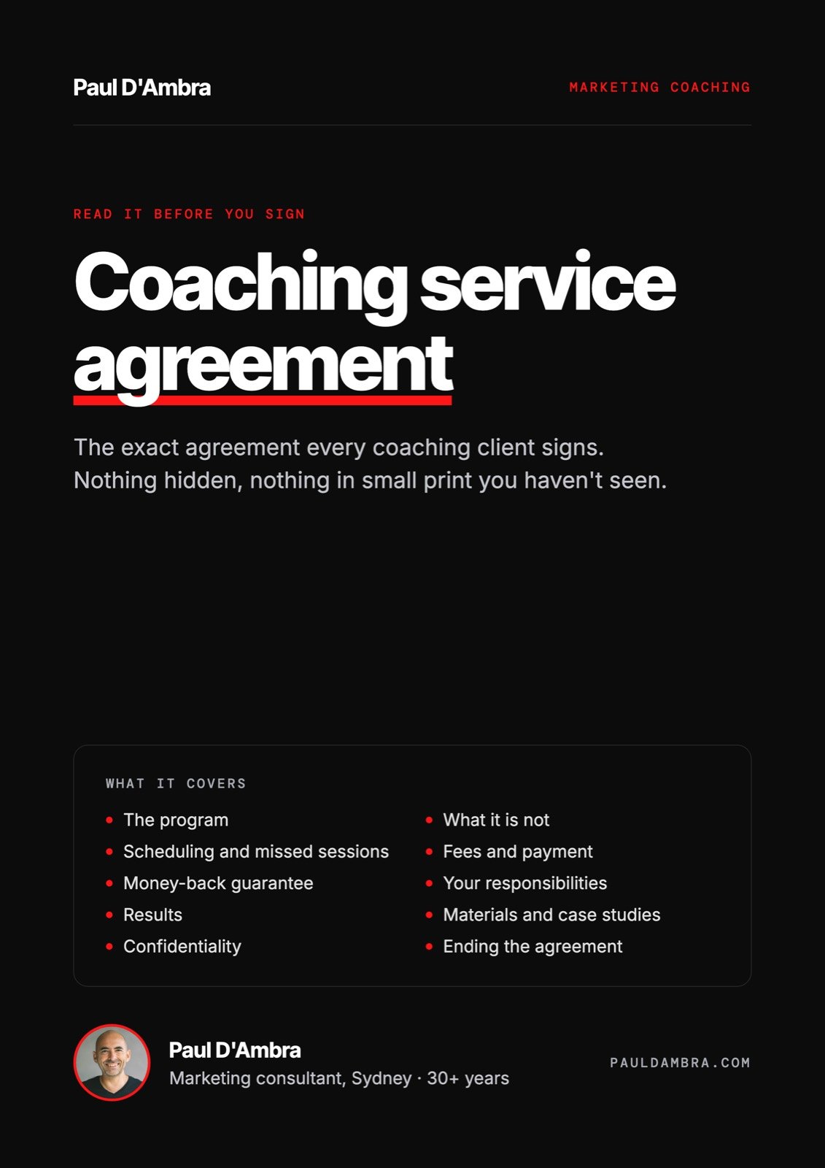

10-week marketing coaching
Coaching service agreement
Between the Client and Paul D'Ambra

This agreement is dated ________________________ and is between:
 | CLIENT | CONTRACTOR
Entity name |  | Paul D'Ambra
Contact name |  | Paul D'Ambra
ABN |  | 77 240 813 694
Address |  | 96A Dunlop Street, Epping NSW 2121
Email |  | ask@pauldambra.com
Mobile / WhatsApp |  | 0414 442 440

In this Agreement, business day means a day other than a Saturday, Sunday or public holiday in New South Wales.

1. The program
1.1 The Contractor will provide the 10-week marketing coaching program described in Schedule A (the Program) to the Client.
1.2 The Program consists of 10 one-to-one coaching sessions of up to 60 minutes each, held online by Google Meet, normally once a week.
1.3 After each session the Contractor will email a written summary of what was discussed and the actions agreed, within 24 hours or by the end of the next business day.
1.4 Between sessions the Client may contact the Contractor by email or WhatsApp with questions about the agreed actions. The Contractor will reply during business hours, normally within one business day. Support between sessions is for questions about the Program only and is not additional consulting or done-for-you work.
1.5 The Client may invite business partners, family members in the business or staff to attend sessions. The Program is for one business only.

2. What the Program is not
2.1 The Program is coaching. The Contractor advises, explains and reviews. The Client, or people engaged by the Client, carry out the work.
2.2 Any work the Client asks the Contractor to carry out, including website changes, content writing, SEO, advertising management or audits, is outside the Program and will be quoted separately before it starts.

3. Scheduling and missed sessions
3.1 Sessions are booked at times agreed between the Parties. The first session will be held within 7 business days of the Contractor receiving the signed Agreement, first payment and completed onboarding questionnaire.
3.2 Either Party may reschedule a session with at least 24 hours notice.
3.3 A session missed by the Client without 24 hours notice is treated as held and counts as one of the 10 sessions.
3.4 All 10 sessions must be used within 16 weeks of the first session. Sessions not used in that period lapse and are not refundable, unless the Contractor agrees otherwise in writing.

4. Fees and payment
4.1 The Client will pay the fee in Schedule B using the payment option ticked in Schedule B.
4.2 Upfront option: the full fee is invoiced on signing and must be paid before the first session.
4.3 Per-session option: each session is invoiced in advance and must be paid before that session is held. The Contractor may postpone a session until its invoice is paid.
4.4 Invoices are due within 5 business days of the invoice date. Interest on overdue amounts and recovery costs apply as set out in clause 12.

5. Money-back guarantee
5.1 The Program includes the money-back guarantee set out in Schedule C. The guarantee applies only on the terms in Schedule C.

6. The Client's responsibilities
6.1 The Client will complete and return the onboarding questionnaire before the first session.
6.2 The Client will give the Contractor reasonable access to the accounts and information needed to review the Client's marketing, such as Google Analytics, Google Search Console, Google Business Profile, website and advertising accounts. Read-only access is sufficient.
6.3 The Client is responsible for deciding whether and how to act on the Contractor's advice, and for the work done by the Client, its staff and its contractors.

7. Results
7.1 The Contractor will provide the Program with due care and skill.
7.2 The Contractor does not promise any particular level of enquiries, leads, sales, traffic, search ranking or AI visibility. Search engines, AI tools, advertising and social platforms are run by third parties who change their systems without notice.

8. Materials and case studies
8.1 Worksheets, templates, checklists, frameworks and methods supplied by the Contractor remain the Contractor's intellectual property. The Client may use them in its own business, but may not resell or republish them.
8.2 Everything the Client creates in the Program, including completed worksheets, plans and content, belongs to the Client.
8.3 Sessions are not recorded unless both Parties agree at the time.
8.4 By signing this Agreement, the Client agrees that the Contractor may describe the Program, the work done with the Client, the methods used and the outcomes achieved, and may name the Client and show its logo, website, listings and other public-facing work, in case studies, reviews, articles, presentations, proposals, social media and on the Contractor's website.
8.5 When doing so, the Contractor will not disclose the Client's commercially sensitive information, including revenue, profit, margins, pricing, financial details, customer or supplier details, login details or internal plans that are not public. Where actual figures would be sensitive, outcomes will be described in general terms or as percentages.

9. Confidentiality
9.1 Each Party will keep the other Party's confidential information, including business plans, pricing, customer information, financial information and login details, confidential and use it only for the Program, subject to clauses 8.4 and 8.5.

10. Ending the Agreement
10.1 Either Party may end this Agreement by written notice at any time.
10.2 If the Client ends the Agreement, sessions already held, or missed under clause 3.3, are payable. If the Client paid upfront, the Contractor will refund the fee for sessions not yet held, less any session missed without notice.
10.3 If the Contractor ends the Agreement for a reason other than the Client's breach, the Contractor will refund the fee for any sessions paid for but not held.

11. Liability
11.1 Neither Party is liable for any indirect or consequential loss, or for loss of revenue, profit, business, goodwill, data or opportunity.
11.2 The Contractor's total liability under this Agreement is limited to the fees paid by the Client for the Program.
11.3 Nothing in this Agreement excludes, restricts or modifies any right or remedy under the Australian Consumer Law that cannot lawfully be excluded.

12. Late payment
12.1 Interest accrues on any amount unpaid after its due date at 15% per annum, calculated daily.
12.2 The Client is liable for reasonable costs of recovering an overdue amount, including debt collection and legal costs.

13. After the Program
13.1 After the 10 sessions the Client may book individual consulting sessions at any time at the Contractor's published rate at the time of booking, or ask the Contractor to quote for doing any of the work. Nothing in this Agreement obliges the Client to do either.

14. General
14.1 The Contractor is an independent contractor. This Agreement does not create an employment, partnership or joint venture relationship.
14.2 If a dispute arises, the Parties will first try to resolve it by talking, by phone, video call or in person, within 10 business days of either Party raising it in writing. This does not delay the recovery of overdue amounts.
14.3 This Agreement, including Schedules A, B and C, is the entire agreement for the Program. Any change must be agreed in writing.
14.4 This Agreement is governed by the laws of New South Wales.
Signed
 | CLIENT | CONTRACTOR
Name |  | Paul D'Ambra
Position |  | Marketing Consultant
Signature
Date
The person signing for the Client warrants they are authorised to do so.

Schedule A
The Program

The Program normally follows this order. The Contractor may adjust the order or emphasis to suit the Client's business.
Week 01 | Foundations
Week 02 | Competitors
Week 03 | Commercial clarity
Week 04 | Public presence
Week 05 | Website
Week 06 | Content + AI
Week 07 | Search + AI visibility
Week 08 | Awareness
Week 09 | Social media
Week 10 | Momentum

Included
☐ 10 × 60 minute one-to-one sessions on Google Meet
☐ Written summary and agreed actions after each session
☐ Email and WhatsApp support between sessions for questions about the agreed actions
☐ The weekly worksheets and the 10-week checklist
☐ Review of the Client's website, Google Business Profile, analytics, advertising and content as part of the sessions

Schedule B · Fee and payment option
Tick one:
☐ Upfront: $2,997 including GST, invoiced on signing
☐ Per session: $350 including GST per session, invoiced before each session ($3,500 including GST over 10 sessions)

Schedule C · Money-back guarantee
Coaching only works if you do the work between sessions. I'm confident enough in this program to put my fee on it: if you do the work and you're not getting value from it, you get your money back.
These terms are here to keep that promise fair for both of us. Most people never need to read past this paragraph.
C1. What the guarantee is
C1.1 If you have completed the first 5 sessions of the 10-week marketing coaching program and you genuinely feel you have not received value from it, I will refund every dollar you have paid for the program.
C1.2 The program then ends. You keep everything you have created, including your worksheets and notes.
C2. Who it applies to
C2.1 You must have completed the first 5 sessions. Sessions rescheduled with at least 24 hours notice still count.
C2.2 You must have sent back the onboarding questionnaire before Session 1.
C2.3 You must have done, or genuinely attempted, the actions we agreed in Sessions 1 to 4, and be able to show what you did. Doing something different instead is not the same as doing the agreed action.
C2.4 You must have given me the access, information and answers I asked for to do my part, such as logins to Google Analytics, Search Console or your website.
C2.5 You must have told me during the sessions if something wasn't working for you. The first I hear of a problem shouldn't be the refund request.
C3. What it does not cover
C3.1 Results that need more time than 5 weeks to show. Search rankings, reviews and referrals build over months. The guarantee is about the value of the coaching, not a promise of a particular number of leads, sales or rankings by Week 5.
C3.2 Things outside either of our control, such as Google, Meta or AI platform changes, market conditions, or decisions made by your staff, contractors or agency.
C3.3 Advice that was not followed, was changed, or was implemented by someone else without checking with me first.
C3.4 Separate consulting sessions, audits or done-for-you work, even if booked during the program.
C4. How to claim
C4.1 Email ask@pauldambra.com within 7 days of Session 5, with "Coaching guarantee" in the subject line.
C4.2 Tell me briefly why the program hasn't been valuable and attach your action tracker or worksheets for Weeks 1 to 4.
C4.3 We'll have a short call within 5 business days. If the conditions above are met, the refund is paid to your nominated account within 10 business days of that call.
C5. The fine print
C5.1 The guarantee applies once per business. Claims after the 7-day window are not accepted.
C5.2 If you paid per session, the refund is the total of the sessions you have paid for. If you paid upfront, the refund is the full upfront amount.
C5.3 These terms form part of your coaching agreement. Nothing in them limits your rights under the Australian Consumer Law.

